**Experiment No. 1**

**Exploratory Data Analysis**

**Student Name: Aayush Gurung UID: 20BCS5323**

**Branch: BE-CSE Section/Group: 607/A**

**Semester: 5th Subject: Machine Learning Lab**

1. **Aim:** We have to implement data analysis on the csv file named titanic train 1.csv. We will use pandas library as it is used for data cleaning and analysis.
2. **Software/Hardware Requirements:** Windows 7 & above version
3. **Tools to be used:**

* Anaconda Navigator
* Jupiter Notebook

1. **Implementation:**

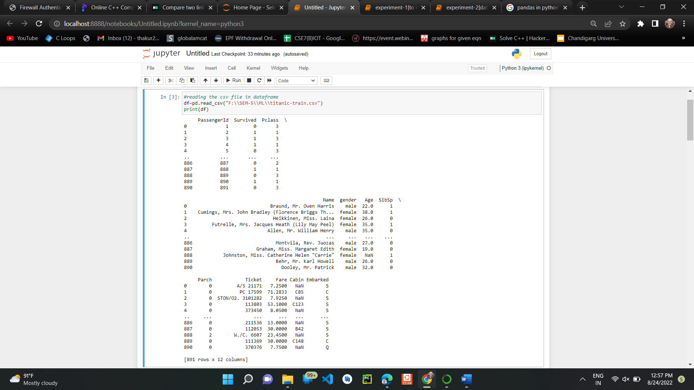

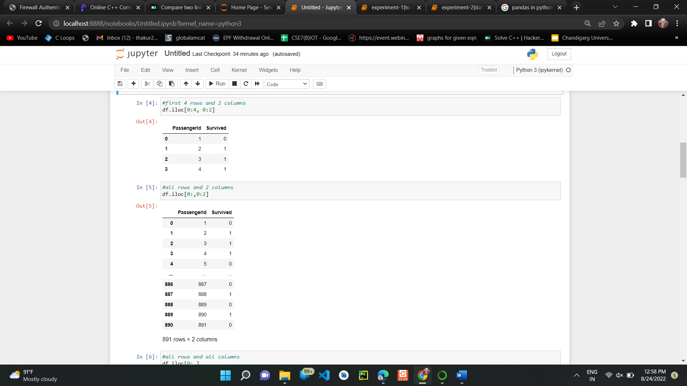

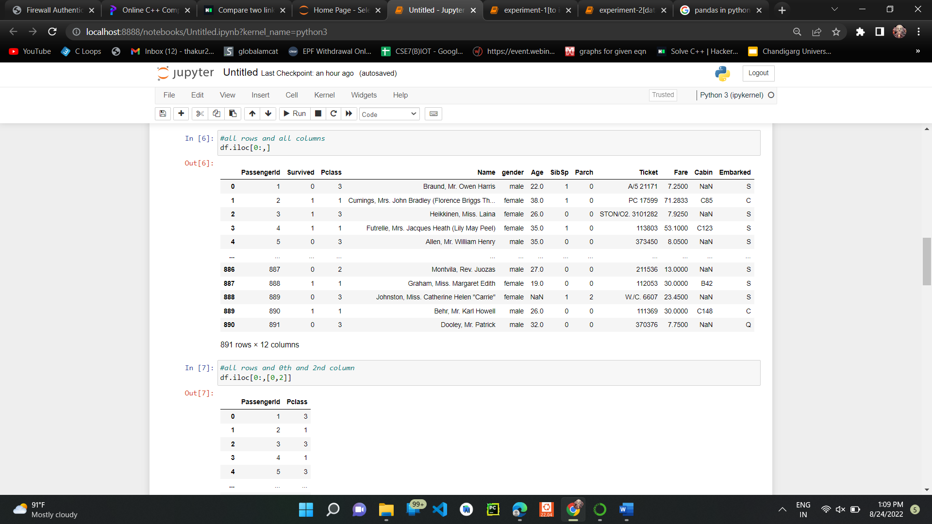

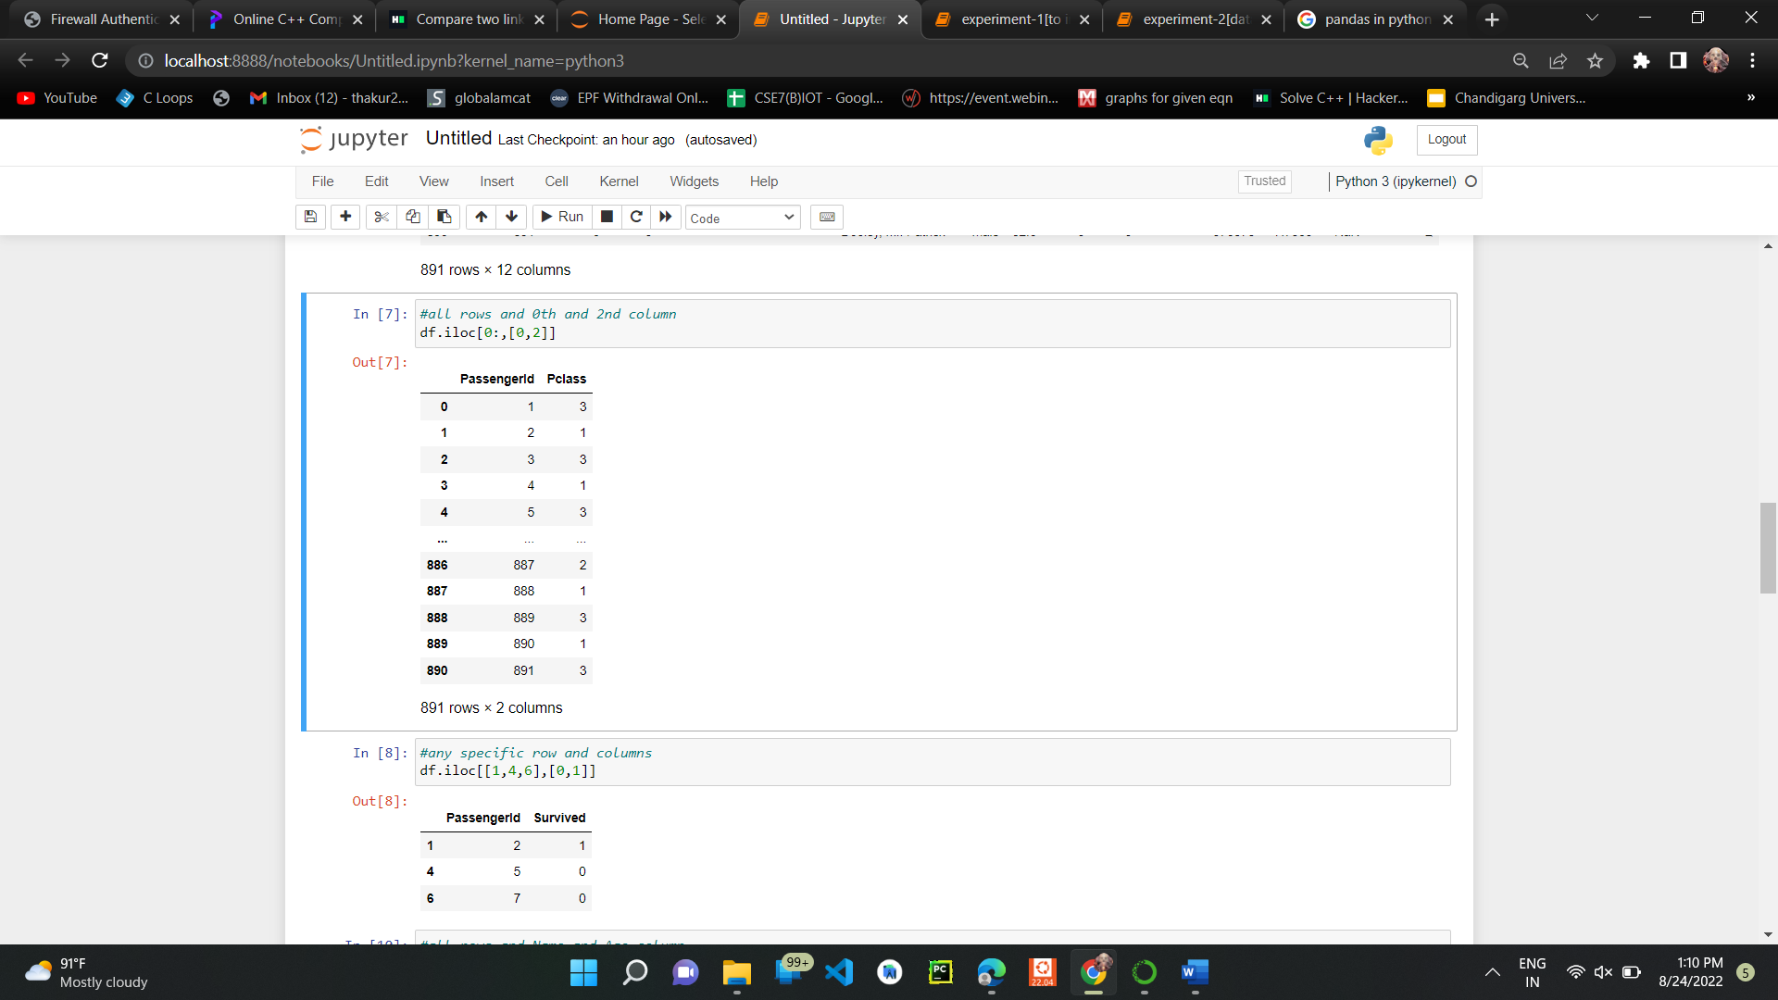

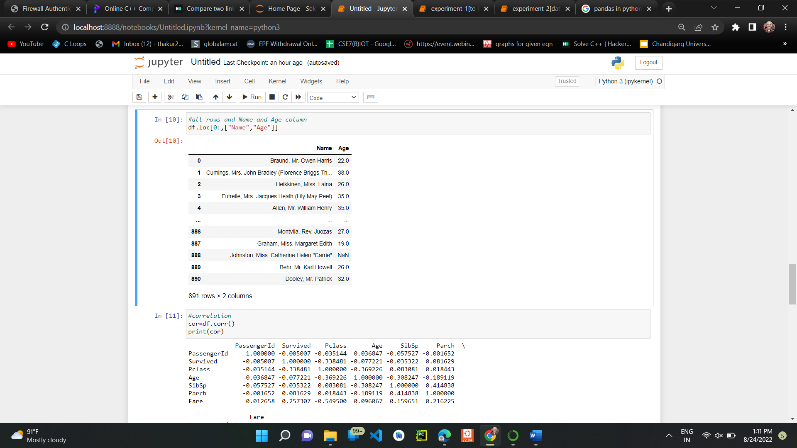

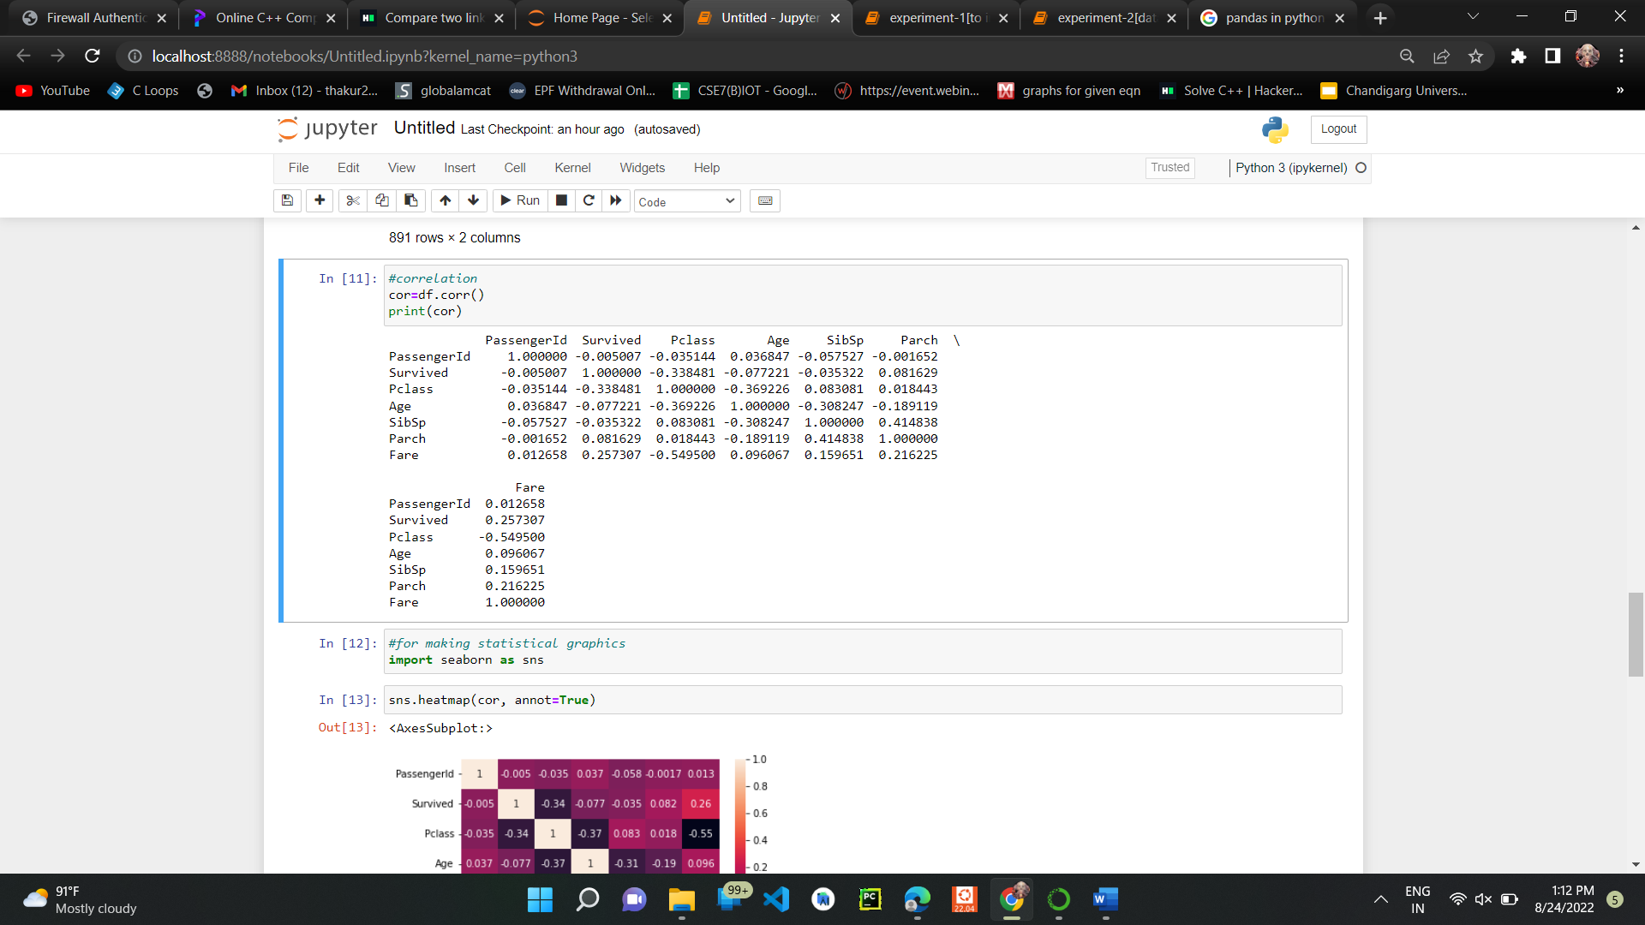

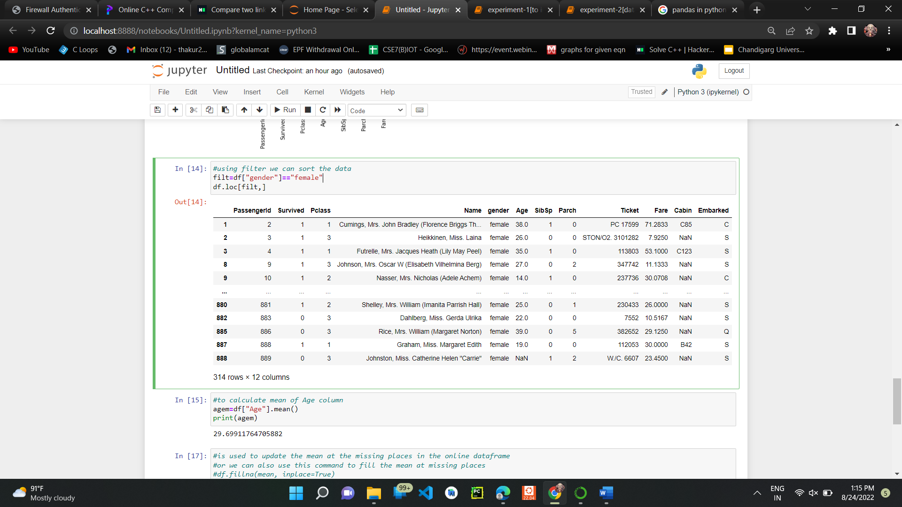

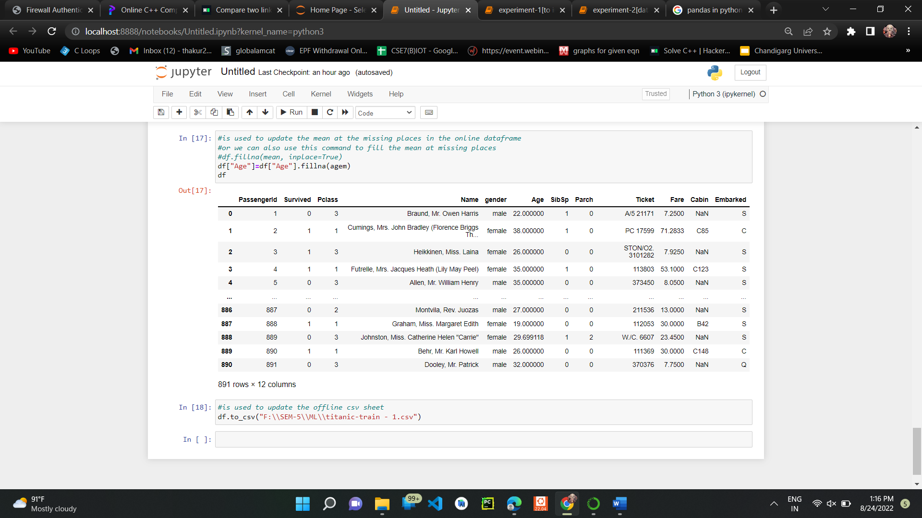

**Output:**

**Before updating the csv sheet:**

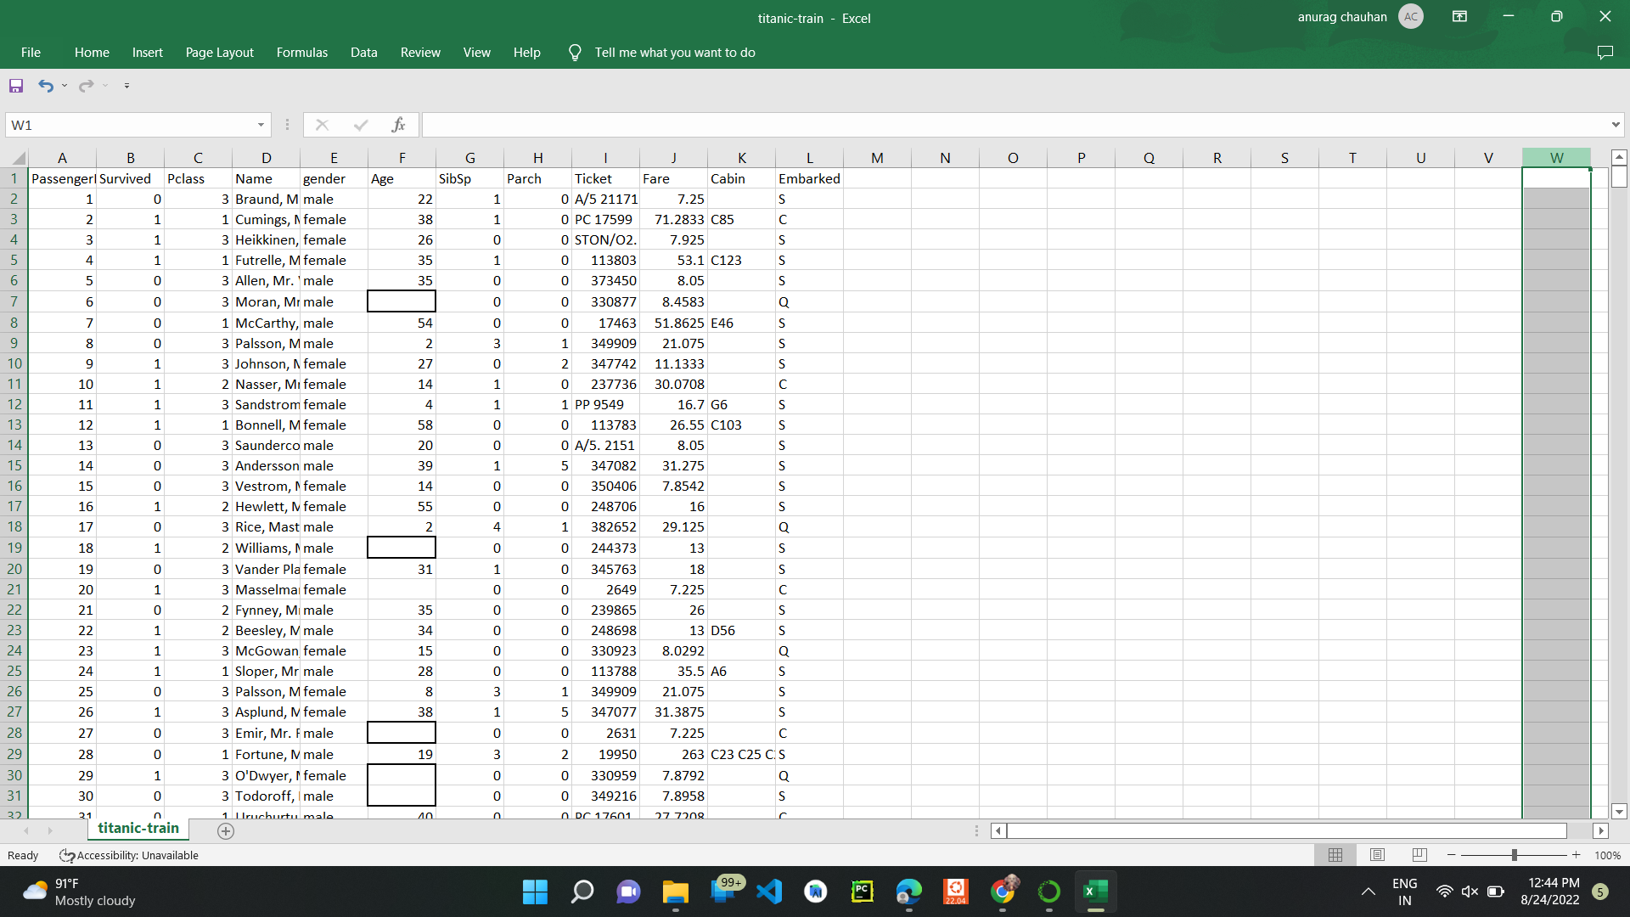

**After inserting the mean at missing value places in the csv sheet:**

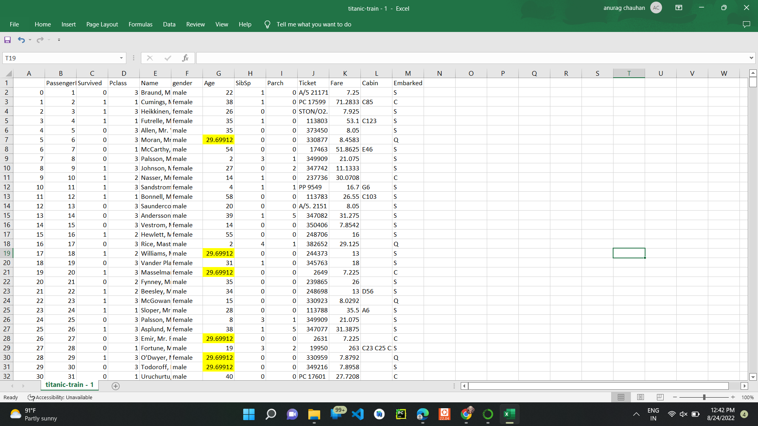

**Learning outcomes (What I have learnt):**

1. Understanding of Exploratory Data analysis.
2. Able to analyze different datasets with the help of python and pandas library.
3. Learning about different library/packages of python.
4. Learning about the different methods, that are needed to analyze the given dataset.
5. Learning of different Machine Learning Functions

**Evaluation Grid :**

|  |  |  |  |
| --- | --- | --- | --- |
| **Sr. No.** | **Parameters** | **Marks Obtained** | **Maximum Marks** |
| **1.** | **Student Performance  (Conduct of experiment) objectives/Outcomes.** |  | **12** |
| **2.** | **Viva Voce** |  | **10** |
| **3.** | **Submission of Work Sheet (Record)** |  | **8** |
|  | **Total** |  | **30** |

**Experiment No. 2**

**Data Visualization**

**Student Name: Aayush Gurung UID: 20BCS5323**

**Branch: BE-CSE Section/Group: 607/A**

**Semester: 5th Subject: Machine Learning Lab**

1. **Aim:** In this experiment we are doing data visualization using python library matplotlib. It offers data visualization packages different features for creating informative, customized and appealing plot to present data in the most simple and effective way.
2. **Software/Hardware Requirements:** Windows 7 & above version
3. **Tools to be used:**

Anaconda Navigator

Jupiter Notebook

1. **Code and Screenshots:**

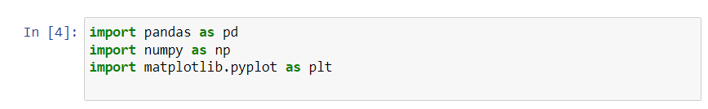

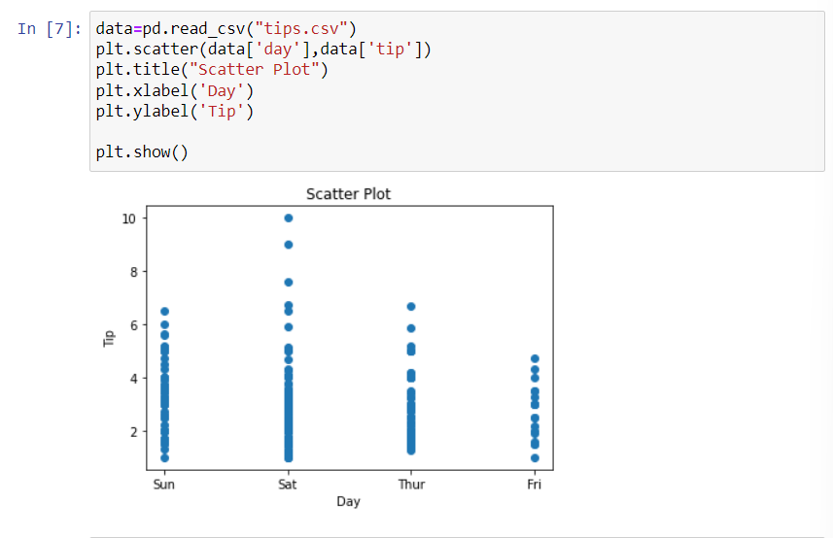

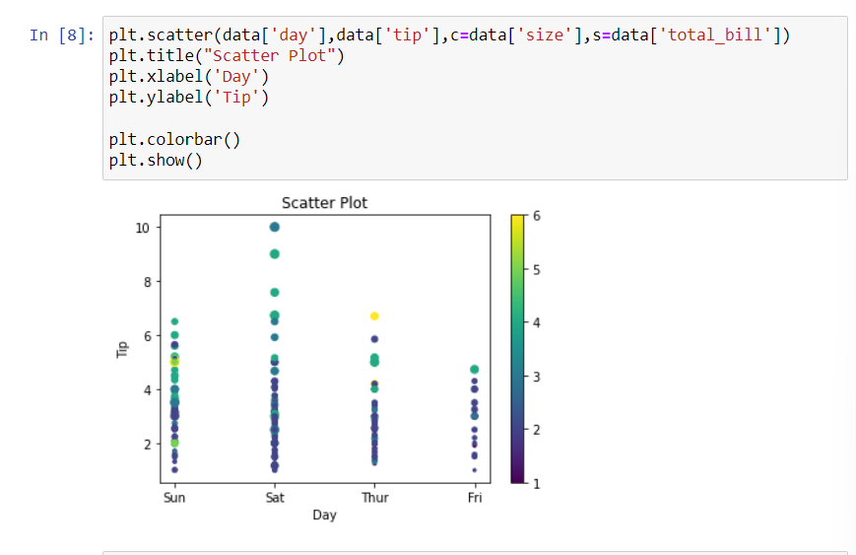

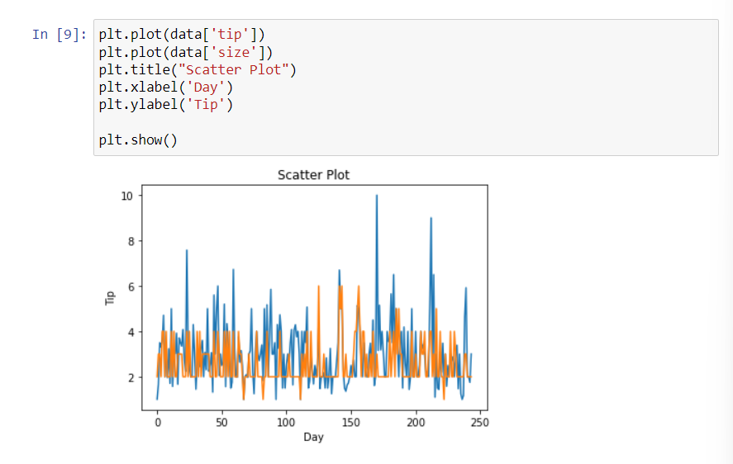

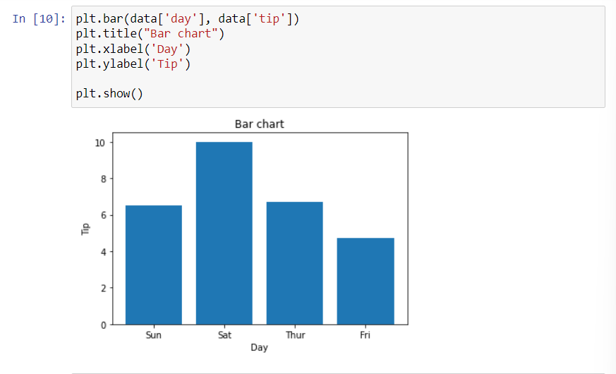

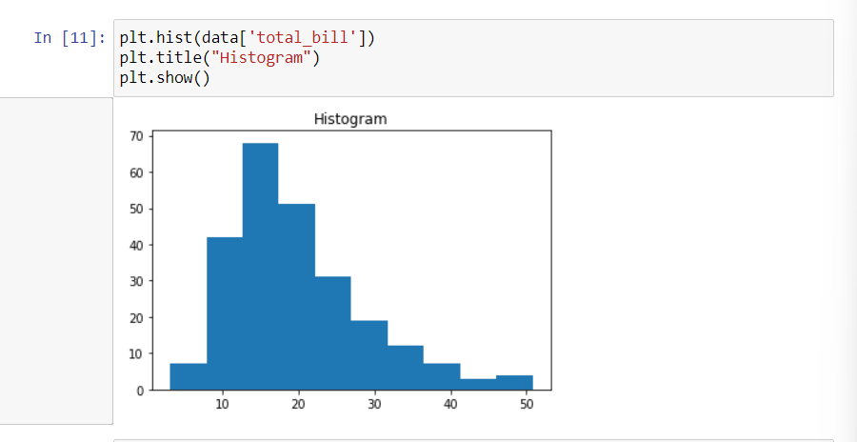

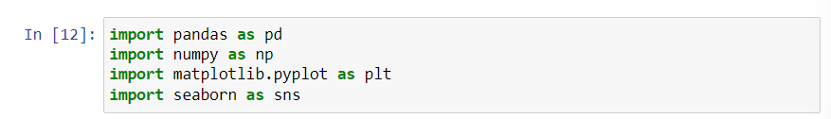

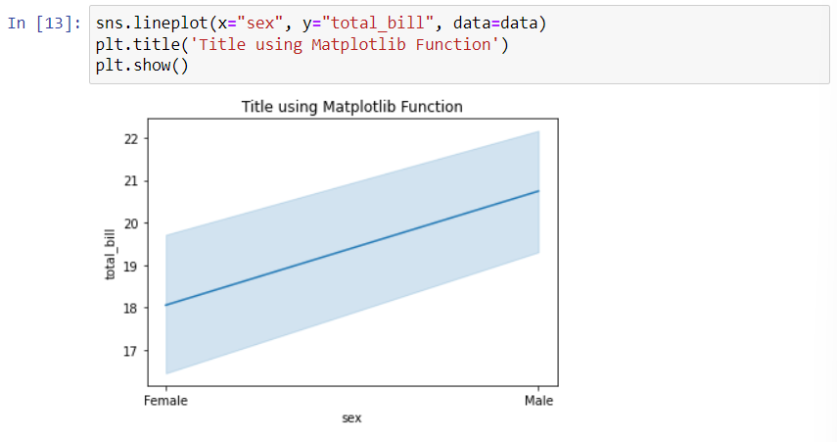

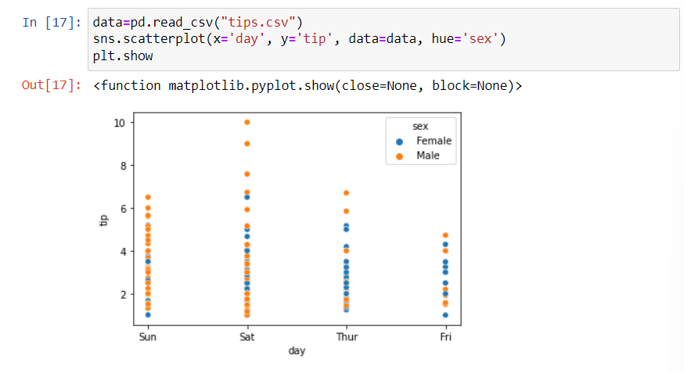

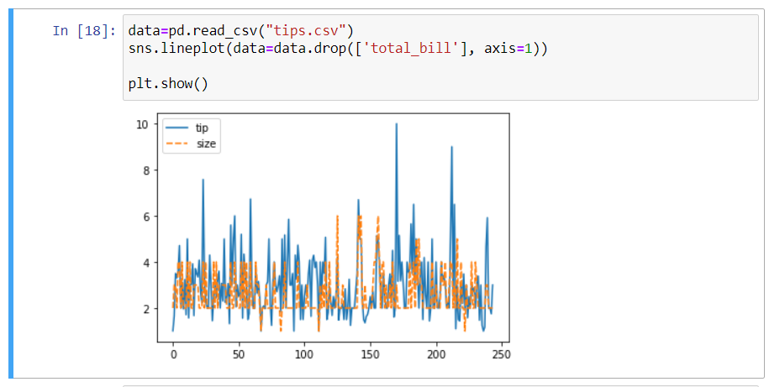

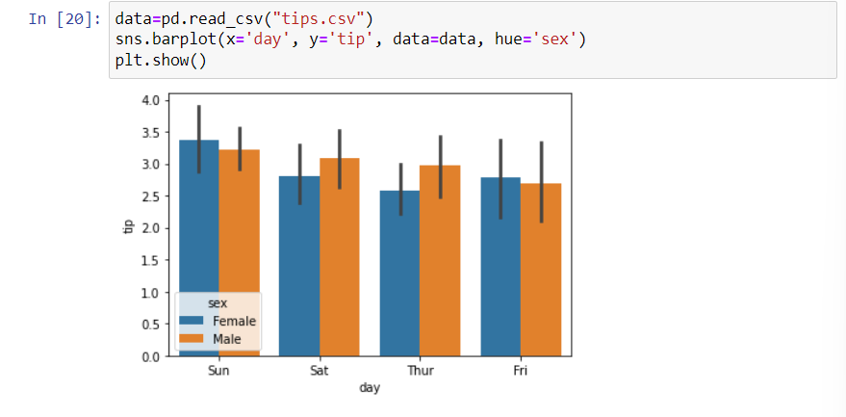

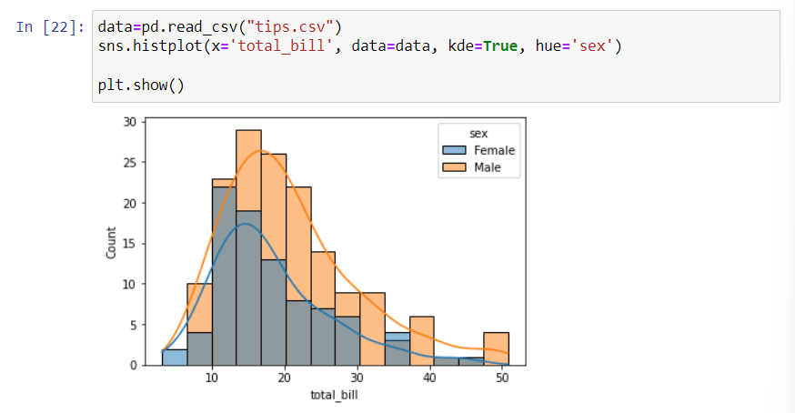

**Learning outcomes (What I have learnt):**

1. Understanding of Data visualization.
2. Able to make different plots on given dataset with the help of python and matplotlib library.
3. Learning about different library/packages of python.
4. Learning of different Machine Learning Functions

**Evaluation Grid :**

|  |  |  |  |
| --- | --- | --- | --- |
| **Sr. No.** | **Parameters** | **Marks Obtained** | **Maximum Marks** |
| **1.** | **Student Performance  (Conduct of experiment) objectives/Outcomes.** |  | **12** |
| **2.** | **Viva Voce** |  | **10** |
| **3.** | **Submission of Work Sheet (Record)** |  | **8** |
|  | **Total** |  | **30** |

**Experiment No. 3**

**Linear Regresssion**

**Student Name: Aayush Gurung UID: 20BCS5323**

**Branch: BE-CSE Section/Group: 607/A**

**Semester: 5th Subject: Machine Learning Lab**

1. **Aim:** Implement Linear Regression on any data set.
2. **Software/Hardware Requirements:** Windows 7 & above version
3. **Tools to be used:**

* Anaconda Navigator
* Jupiter Notebook

1. **Implementation:**

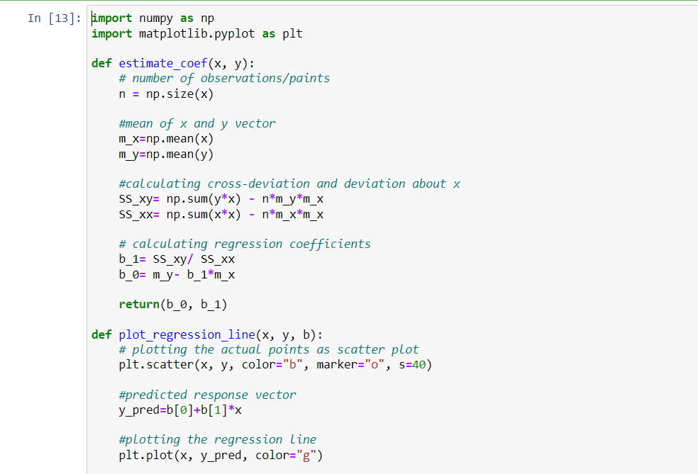

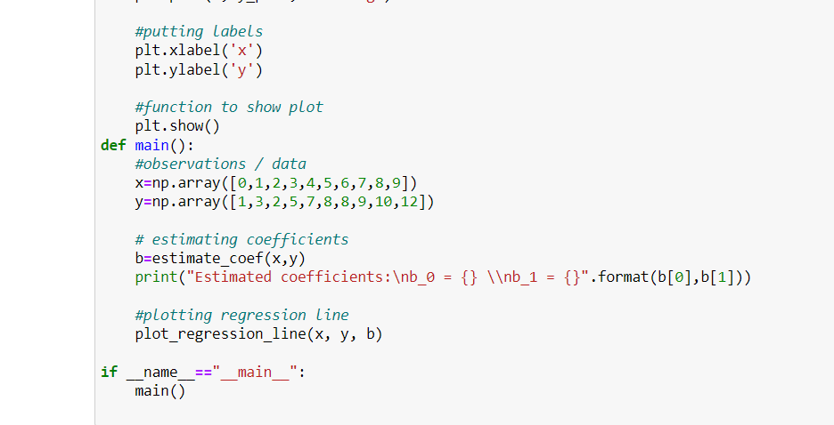

1. **Output:**

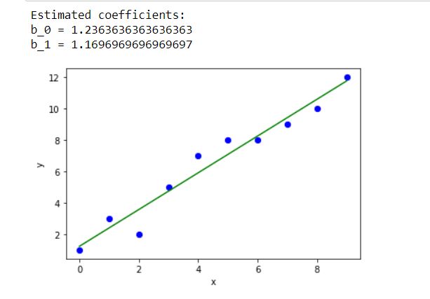

**Learning outcomes (What I have learnt):**

1. Understanding of Linear regression.
2. Able to implement linear regression on any given dataset.
3. Learning about different library/packages of python.
4. Learning of different Machine Learning Functions

**Evaluation Grid :**

|  |  |  |  |
| --- | --- | --- | --- |
| **Sr. No.** | **Parameters** | **Marks Obtained** | **Maximum Marks** |
| **1.** | **Student Performance  (Conduct of experiment) objectives/Outcomes.** |  | **12** |
| **2.** | **Viva Voce** |  | **10** |
| **3.** | **Submission of Work Sheet (Record)** |  | **8** |
|  | **Total** |  | **30** |